Create Previous Day Counts:
Run Location Activity Report found in the Synapse Inventory Control Folder
Remove STG and Door locations, copy remaining locations to another column and remove duplicates, copy and paste remaining locations into the cycle count program leaving all fields clear
To create PF only counts copy all locations to count but enter PF in the location type field, preassign to inventory specialist, make sure Exclude No Service Locations is checked. To create Storage only enter STO and copy and paste all locations.
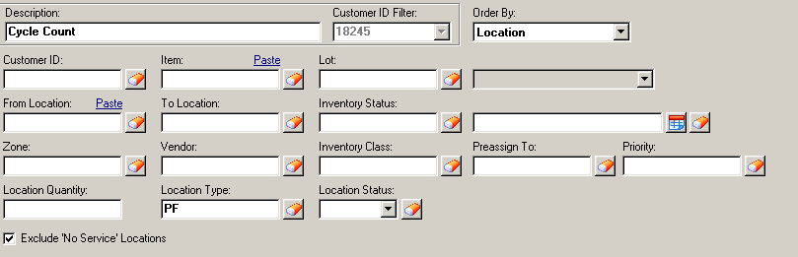
Check suspended plates throughout the day to clear daily. Assign second count to another counter.
Suspended Plates MUST be cleared daily!
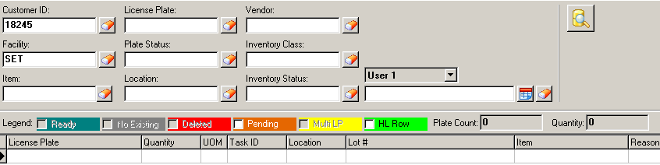
Adjustment process for count variances:
- IC team members will have previous day counts assigned to them by IC Supervisor daily
- IC team members will go to locations to count by using RF gun and enter count
  - If there is a variance the location will be put on hold and all locations will be counted for that item. Counter will use a laptop to drop locations in excel and update system qty for each location when they arrive to ensure system qty has not changed as picking is occurring
  - Counts will then be processed into the RF gun at the time count has completed per location

    - Variances
      - If the is a positive adjustment after all locations have been counted the IC Specialist will enter the overage quantity in the RF gun and assign themselves the 2nd count and clear the suspended plates.
      - Overage product will then be moved onto a new LP into the OVRCAGE where the material will be placed inside overage cage until approved to move back into pick front from customer
      - If there is a negative adjustment the same process will occur, but the missing product will be moved into the VECO-30 location and suspended plates will be deleted so the product will not be adjusted out of the system

- IRR reports will be filled out by Supervisor for any of the above adjustments and sent to customer same day after researching
- Any variances will have to be entered manually to the daily Cycle Report that goes to the customer at end of day since the system will not populate these transactions on the report
]
- Random audits will be completed by Supervisor to ensure any adjustments made are accurate to confirm the inventory integrity

Run following reports daily to maintain Inventory Accuracy: (run multiple through the day)
- Item in wrong pick front report – Found in Inventory Control Folder.
Locate product in wrong locations and move to dedicated pick front along with systematically moving
- Location Clean up report – Found in Inventory Control Folder
This shows any location that is out of service but shows plates. If you do not clear these daily the inventory will not show on your reports and system will never task a replenishment or order to the location. If any plate shows a negative quantity, it needs to be sent to IT support to correct.
- Locations with Multiple Items – Found in Standard Reports Folder
Report shows all locations with more than one item in location. This needs to be cleared asap to ensure product is located in correct bin and prevent shipping errors.
- Items without a pick front – Found in Standard Reports Folder
Report shows all items that do not have a pick front assigned, all items need to have a pick front to ensure items are not being picked from storage locations.
- Multi Plates – Go to License plate look up screen and click on multi plates, this shows any LP’s that were created while receiving or combining LP’s, when this is created it doubles the inventory totals. To correct you must 13 the multi plate onto another LP. Contact employee’s supervisor so person can be retrained.

`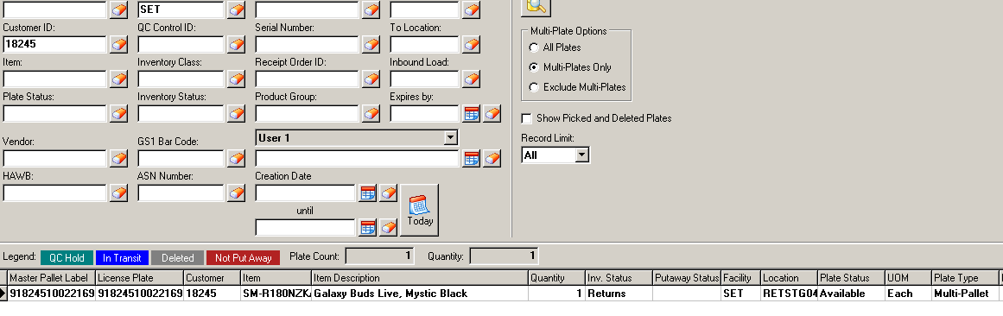

- Aged plates in Stage and Door locations – This should be checked weekly to ensure all orders are closed and not left in picking or loading status. Go to license plate look up and enter from and to STG locations for picking and doors. Sort my last update column and any left open from previous days should be sent to Operations to investigate right away.

- Returns material in available locations – Needs to be checked daily before end of day to ensure all items are in available status when product is received. Go to license plate look up enter RT, DM in the inventory status field, this will show all status’s for returns and damaged. Sort by location to ensure product is not in available inventory locations. If product is found correct to available status and notify operations for retraining.

- Skip Picks – Run Labor Activity Report in Inventory Control folder. Filter by SKPK and PKME then file by picks. This is number of locations that have been skipped during picking process. Will need to find out why they are skipping, is there is an issue with pick front, if waiting on replenishments check min -max to ensure maximum qty is being replenished. Are we out of stock, validate none left in storage locations. Research.

- Short Picks – Labor Activity Report, shows locations that are skipped during picking process identifying that on one can pick from the location due to being short product. Filter report by event PKNO then filter by PICK. Need to identify where this location is being short picked, system will automatically send a CC for this location when this code is used during picking.

- Put away Overrides – Labor activity report, why are they overriding, is there product in location are they trying to increase productivity? Need to work with Operations to find out why there are overrides. If there is an issue with location this needs to be communicated to IC team. Filter by LPPA and PUTR then by PCHG.

- License Plate manual Moves – Labor Activity Report – Filter by LPMV, there should be no manual moves to storage or pick fronts, if this occurs you need to work with Operations to find out why they are not following process of replenishments and put away.

- Cancelled Orders still showing plates - License plate lookup, enter S in plate status field then enter. Double click on “Addl Info” tab This is very important, if order is cancelled before being de-picked the plate will still show as inventory. All orders have to be de-picked before canceling.

- Inventory Adjustments – Go to Look up screen, Adjustment to inventory. Verify no one is using CC code except for true adjustments. For any adjustment that is not a true CC there are other adjustment codes to use. If CC is used for any reason besides true adjustments this will skew your reporting to the customer.

- Oh Hold, IC Hold and Receipt Hold – License plate look up enter OH, IC, RH in inventory status field. Validate product is actually supposed to be on hold, if so the product should be removed from the pick front immediately, same with IC hold. If product is showing receipt hold then status needs to be updated to available.

Empty Bin Audit – Standard Reports, Empty location report. This report should be downloaded into excel and completed weekly. All issues found would need to be communicated by error form to teammates supervisor.

